Meta Title:
Best Jewelry Repair in Greensboro NC | Crystal Jewelers
Meta Description:
Restore your jewelry and watches with Crystal Jewelers' the best jewelry Repair greensboro nc store. Trusted for gold, silver, diamond, and antique repairs.
BEST JEWELRY REPAIR greensboro nc | h1
best jewelry repair near me
best jewelry & watch repair
best jewelry repair nyc
best JEWELRY REPAIR store near me
jewelry repair greensboro
jewelry repair greensboro nc
best jewelry repair shop near me
gold jewelry repair
gold jewelry repair near me
antique jewelry repair
antique jewelry repair near me
silver jewelry repair
silver jewelry repair near me
Diamond Jewelry Repair
Watch Repair Greensboro nc | h2
Rolex Watch Servicing
Watch Batteries Near me
watch repair near me
watch repair shop near me
rolex watch repair near me
watch repair shops near me
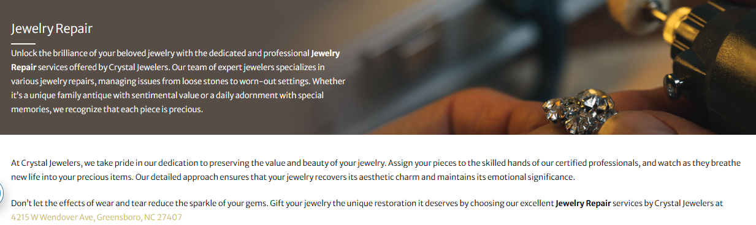

BEST JEWELRY REPAIR Greensboro NC(H1)
Discover the brilliance of your beloved jewelry with the dedicated and professional best Jewelry & Watch Repair services offered by Crystal Jewelers. Our team of expert jewelers offers the best jewelry repair in Greensboro NC, managing issues from loose stones to worn-out settings. Each piece of jewelry in your collection holds special value in your eyes and our experts understand it very well.
At Crystal Jewelers, our professional experts take care of of your jewelry by preserving its true value and beauty through excellent craftsmanship. Not only do our experts add new life to your jewelry, but they also make them mesmerizing piece of art for you. With a keen eye to detail, our experts will make sure your jewelry maintains its charm and glory like the day you purchased.

So, don’t let the effects of wear and tear reduce the shine of your gems. Gift your jewelry the unique restoration it deserves by choosing our best jewelry repair near me services by Crystal Jewelers at 4215 W Wendover Ave, Greensboro, NC 27407.
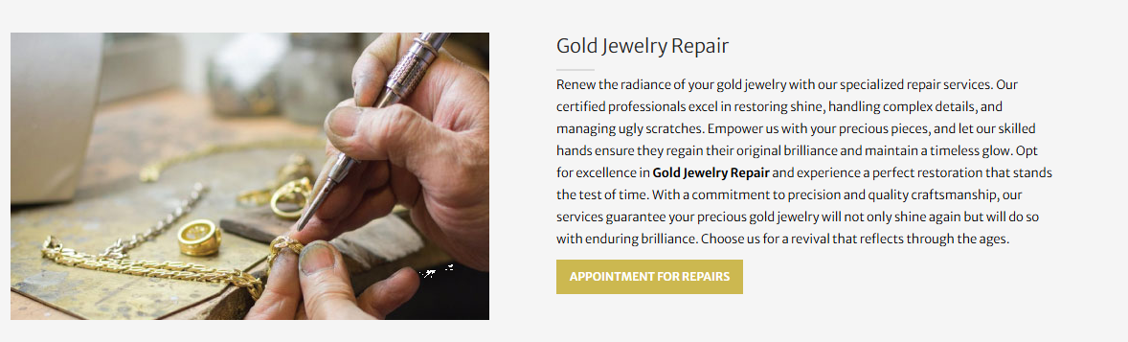

Gold Jewelry Repair (H2)
Renew the radiance of your gold jewelry with our specialized gold jewelry repair near me services. Our certified professionals excel in restoring shine, handling complex details, and managing ugly scratches. Empower us with your precious pieces, and let our skilled hands ensure they regain their original brilliance and maintain a timeless glow. You can opt for our Gold Jewelry Repair services to experience the art of true craftsmanship of our experts. Our experts will restore your jewelry & watch to its perfect condition through commitment to precision and excellent craftsmanship. Choose us for a revival that reflects through the ages.
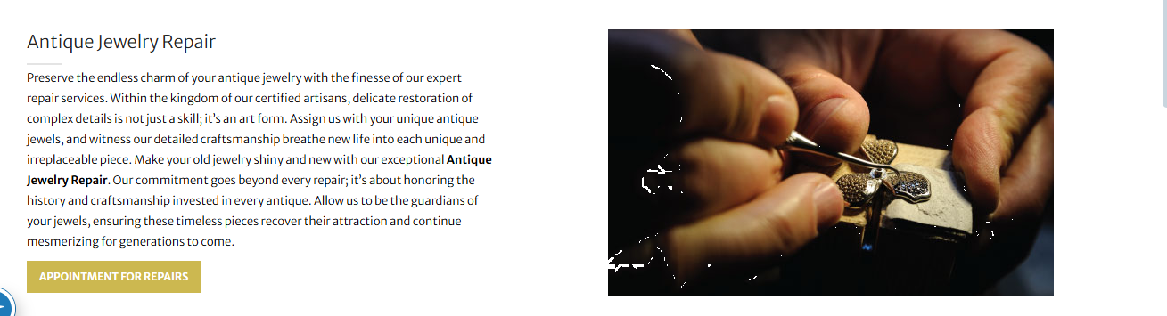

Antique Jewelry Repair (H2)
Preserve the endless charm of your antique jewelry with the finesse of our expert antique jewelry repair near me services. Within the kingdom of our certified artisans, delicate restoration of complex details is not just a skill; it’s an art form. You can hand over to us your antique jewels and we will make sure they get a new life like the day one you purchase them. Our experts will make sure your old jewelry shines like never before through our exceptional Antique Jewelry Repair. Our jewelry repair greensboro nc store commitment goes beyond every repair; it’s about honoring the history and craftsmanship invested in every antique. Allow us to be the guardians of your jewels, ensuring these timeless pieces recover their attraction and continue mesmerizing for generations to come.
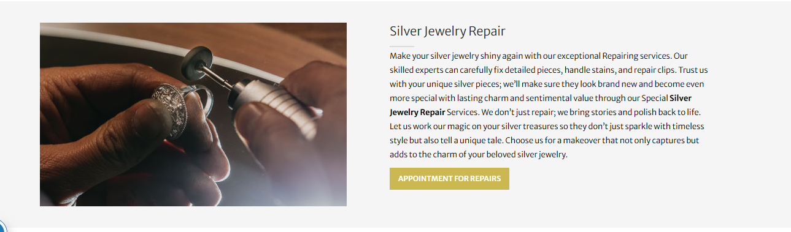

Silver Jewelry Repair (H2)
Make your silver jewelry shiny again with our silver jewelry repair near me services. Our skilled experts carefully fix detailed pieces, handle stains, and repair clips. Trust us with your unique silver pieces; we’ll make sure they look brand new and become even more special with lasting charm and sentimental value through our Special Silver Jewelry Repair Services. We don’t just repair; we bring stories and polish back to life. Let us work our magic on your silver treasures so they don’t just sparkle with timeless style but also tell a unique tale. Choose our best jewelry repair Greensboro store for a makeover that not only captures but adds to the charm of your beloved silver jewelry.
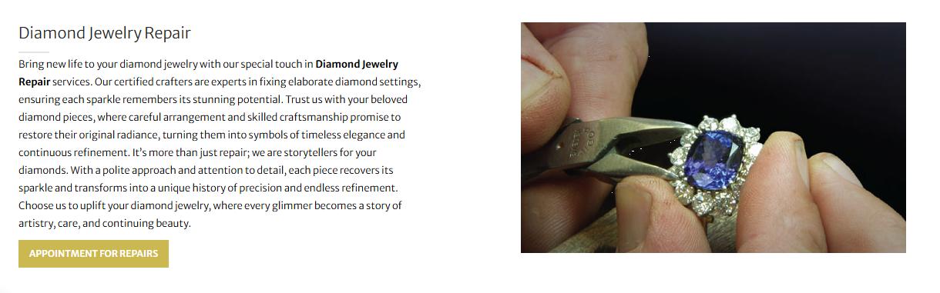

Diamond Jewelry Repair (H2)
Bring new life to your diamond jewelry with our special touch in Diamond Jewelry Repair services. Each piece recovers its sparkle and transforms into a story of precision and endless refinement. Trust us with your beloved diamond pieces, where careful arrangement and skilled craftsmanship promise to restore their original radiance, turning them into symbols of timeless elegance and continuous refinement. It’s more than just repair; we are storytellers for your diamonds. With a polite approach and attention to detail, each piece recovers its sparkle and transforms into a unique history of precision and endless refinement. Choose us to uplift your diamond jewelry, where every glimmer becomes a story of artistry, care, and continuing beauty.
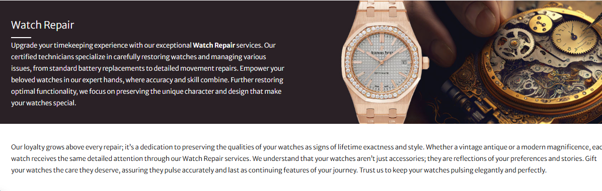

Watch Repair Greensboro NC (H2)
Upgrade your timekeeping experience with our exceptional watch repair near me services. Our certified technicians restore watches with accuracy, from battery replacements to movement repairs. Empower your beloved watches in our expert hands, where accuracy and skill combine. Further restoring optimal functionality, we focus on preserving the unique character and design that make your watches special.

Our loyalty grows above every repair; it’s a dedication to preserving the qualities of your watches as signs of lifetime exactness and style. Our watch repair services deal each watch style whether it be vintage antique or modern stylish with same dedication and attention to detail. We believe that your watch showcase who you are that’s why every watch gets special attention from our experts. Gift your watches the care they deserve, assuring they pulse accurately and last as continuing features of your journey. Trust us to keep your watches pulsing elegantly and perfectly.
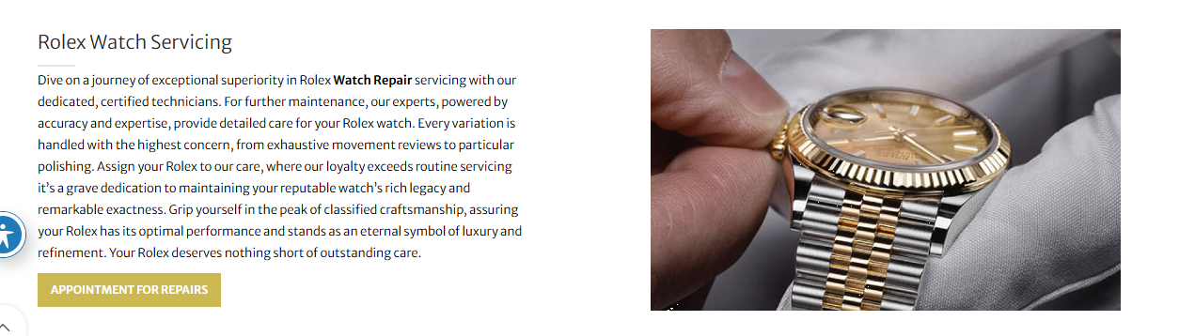

Rolex Watch Servicing (H2)
Dive into exceptional superiority in Rolex watch repair near me with our certified technicians. Every variation is handled with grave dedication to preserve your watch’s legacy. For further maintenance, our experts, powered by accuracy and expertise, provide detailed care for your Rolex watch. Every variation is handled with the highest concern, from exhaustive movement reviews to particular polishing. Assign your Rolex to our care, where our loyalty exceeds routine servicing. It's a grave dedication to maintaining your reputable watch’s rich legacy and remarkable exactness. Grip yourself in the peak of classified craftsmanship, assuring your Rolex has its optimal performance and stands as an eternal symbol of luxury and refinement. Your Rolex deserves nothing short of outstanding care.
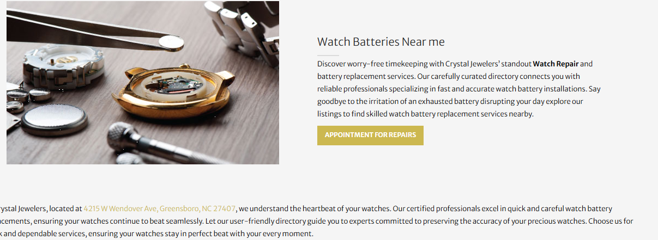

Watch Batteries Near me (H3)
Discover worry-free timekeeping at watch repair shops near me with Crystal Jewelers’ standout battery replacements. Our carefully curated directory connects you with reliable professionals specializing in fast and accurate watch battery installations. Say goodbye to the irritation of an exhausted battery disrupting your day, and explore our listings to find skilled watch battery replacement services nearby.
At Crystal Jewelers, the best jewelry repair shop near me, located at 4215 W Wendover Ave, Greensboro, NC 27407, we prioritize precision.Our certified professionals excel in quick and careful watch battery replacements, ensuring your watches continue to beat seamlessly. Let our user-friendly directory guide you to experts committed to preserving the accuracy of your precious watches. Choose us for quick and dependable services, ensuring your watches stay in perfect beat with your every moment. Visit our watch repair shop near me for seamless care.

